**Assignment: Python Programming for GUI Development**

Name: T. Yogananda Reddy

Register Number:192365058

Department: Computer Science & Engineering-(CS)

Date of Submission: 24-08-2024

**Problem 3:** **Real-Time Traffic Monitoring System**

**Scenario:**

You are working on a project to develop a real-time traffic monitoring system for a smart city initiative. The system should provide real-time traffic updates and suggest alternative routes.

**Tasks:**

1. **Model the Data Flow:** Create a data flow diagram illustrating how the system will fetch real-time traffic information from an external API and display it to user.
2. **Implement a Python Application:** Develop a python application that integrates with traffic monitoring API (e.g., Google Maps Traffic API) to fetch real time traffic data.
3. **Display Traffic Information:** Show the current traffic conditions, estimated travel time, and any incidents or delay to the user.
4. **User Input:** Allow users input a starting point and a destination, and display the corresponding traffic updates and alternative routes.

**Deliverables:**

* **Data Flow Diagram**: Provide a diagram showing the interaction between the application and the API.
* **Pseudocode and Implementation**: Write the pseudocode and implement the traffic monitoring system in Python.
* **Documentation**: Document the API integration and the methods used to fetch and display traffic data.
* **Explanation**: Include any assumptions made and potential improvements that could be made to the system.

# Solution:

# Real-Time Traffic Monitoring System

# 1.Data Flow Diagram

**User**

Start and end point

**API Key and Configuration**

Location Data API key & config Data

**Fetch Traffic Data**

API Request

**Traffic API**

**Display Traffic Information**

# 2. Implementation

|  |
| --- |
| # Pseudocode:  # 1. Import necessary libraries.  # 2. Set up the API key and base URL.  # 3. Define a function to fetch traffic data based on user input (start point and destination).  # 4. Process the API response to extract relevant traffic information.  # 5. Display the traffic data (current conditions, travel time, incidents).  # 6. Allow the user to input different locations and repeat the process.  # Implementation:  import requests  def get_traffic_data(api_key, start_point, destination):  # Base URL for traffic data  base_url = "https://maps.googleapis.com/maps/api/directions/json"    # Set up the parameters for the API request  params = {  "origin": start_point,  "destination": destination,  "key": api_key,  "departure_time": "now"  }    # Make the API request  response = requests.get(base_url, params=params)  data = response.json()    if "routes" in data and len(data["routes"]) > 0:  # Extract relevant information  route = data["routes"][0]  legs = route["legs"][0]  traffic_info = {  "start_address": legs["start_address"],  "end_address": legs["end_address"],  "distance": legs["distance"]["text"],  "duration": legs["duration"]["text"],  "duration_in_traffic": legs.get("duration_in_traffic", {}).get("text", "N/A"),  "traffic_conditions": legs.get("traffic_speed_entry", [])  }  return traffic_info  else:  return None  def display_traffic_info(traffic_info):  if traffic_info:  print(f"Start Address: {traffic_info['start_address']}")  print(f"End Address: {traffic_info['end_address']}")  print(f"Distance: {traffic_info['distance']}")  print(f"Estimated Travel Time: {traffic_info['duration']}")  print(f"Travel Time in Traffic: {traffic_info['duration_in_traffic']}")  print("Traffic Conditions:")  for condition in traffic_info["traffic_conditions"]:  print(condition["description"])  else:  print("No traffic data available for the given route.")  # Example usage:  api_key = "YOUR_API_KEY"  start_point = "Kurnool"  destination = "Hyderabad"  traffic_info = get_traffic_data(api_key, start_point, destination)  display_traffic_info(traffic_info) |

# 3.Display the Current traffic information

**Start Address:** Kurnool, Andhra Pradesh, India

**End Address:** Hyderabad, Telangana, India

**Distance:** 213 km

**Estimated Travel Time:** 4 hours 30 minutes

**Travel Time in Traffic:** 5 hours 10 minutes

**Traffic Conditions:**

Slow traffic near Kurnool

Moderate traffic near Hyderabad

# 4.User Input

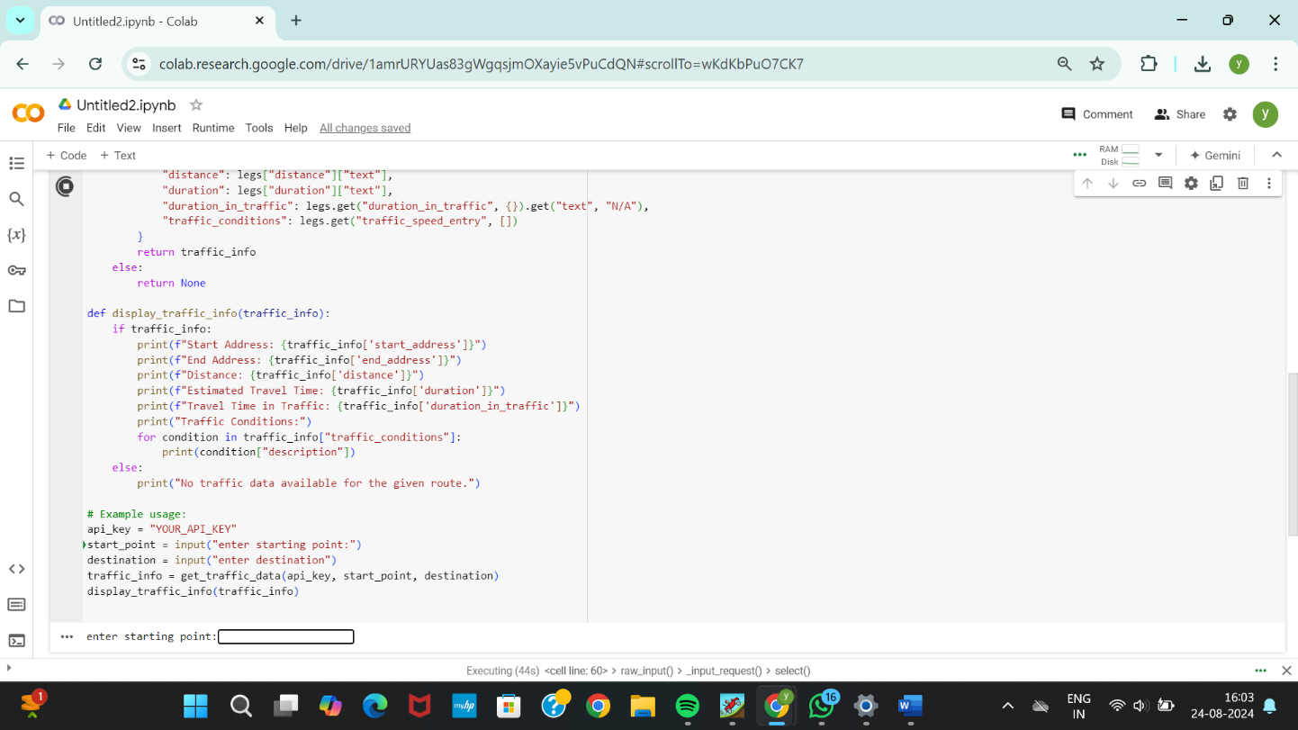

**5.Documentation**

# API Integration: The system uses the Google Maps Directions API to fetch real-time traffic data. The API request includes parameters for the start and end points, API key, and departure time.

# Methods Used: The traffic data is fetched using the requests library in Python. The API response is processed to extract relevant traffic information, which is then displayed to the user.

# Assumptions: It is assumed that the user provides valid start and end locations, and that the API key is correctly set up with the necessary permissions.

# Potential Improvements: The system could be enhanced by adding features like real-time updates, push notifications for traffic alerts, and integration with a map interface for visualizing the route.

# ­­­­­